**Replacing Few Characters from string, copy source file to destination, explore all string subactions**

**4.1 – Replacing the characters from the string**

**Problem Statement:**

1) Take the string input from user .

1. Take the part of String to be replaced as input.
2. Take the string which has to added in place of replaced text.
3. Replace the string/characters and show the newly formed string.

**Controls used:**

1. **Prompt: For Value**

Prompt: For Value control opens dialogue box on the desktop and ask for input. Then we can store the input value into custom variable for future operations.

1. **String: Replace**

String: Replace replaces the string, we have to specify the string to be replaced and the string that has to be inserted in place of that. It stores that newly formed string into the variable as we provided.

1. **Message Box**

Message Box : Message box simply displays the messages or texts that we have setted to be displayed.

**Steps to create and execute bot to achieve above task:**

**Step1:** Create a new bot by clicking on Home page of Automation Anywhere, Click on Create bot option. Give the bot name and click on “Create and edit”.

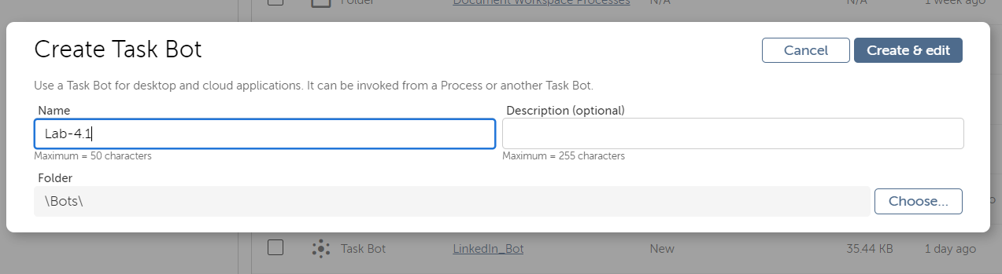

**Step 2:** Add Prompt: For Value control. Select new window and choose Google Chrome Tab from the drop down. Give the LinkedIn Login page link-www.linkedin.com

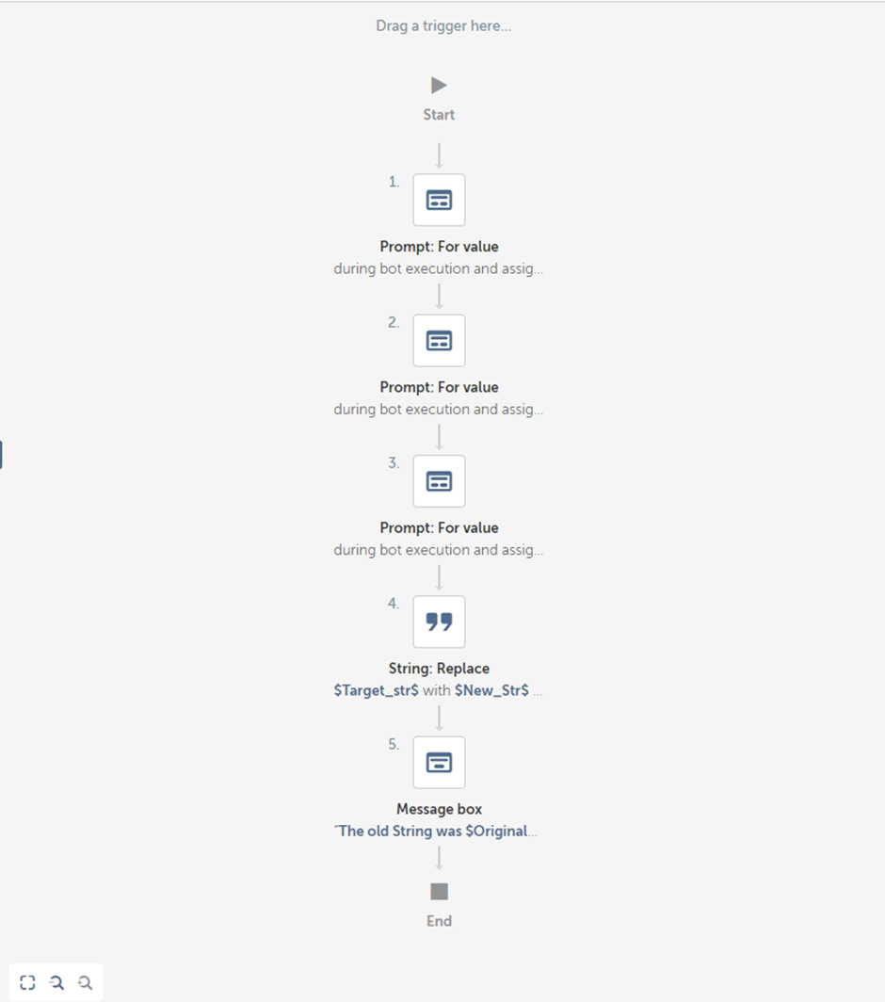

**Step 3:** Add a capture control to capture the field from the web page. Select browser window and then click on capture object.

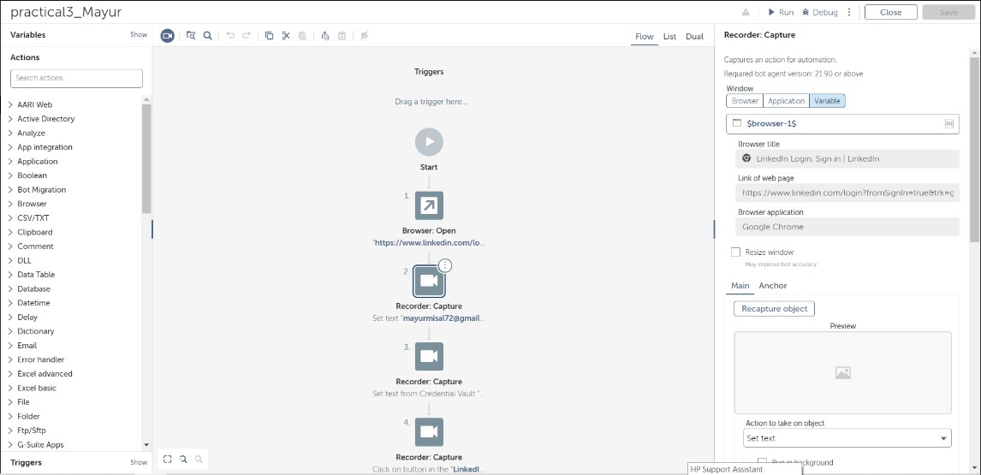

**Step 4**: Capture the Email Object in which we enter Email.



**Step 5:** Select the Action as set text to enter the text in Email. For Example- mayurmisal72@gmail.com

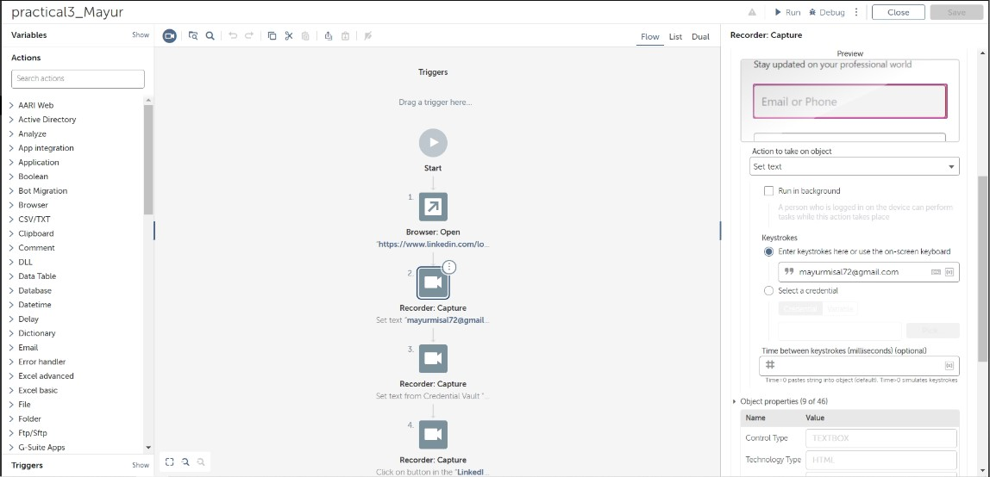

**Step 6:** For the password to enter securely, create the credentials for password. Give Credential name and Attribute name. Give your LinkedIn password in value field with security as masked and click on “Create Credentials”.

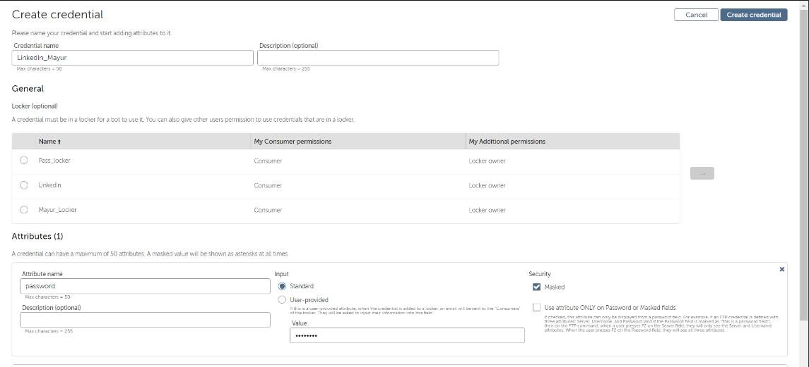

**Step 7:** Create a Locker for the credentials created above, give the locker name and select the credential for which locker is created and click on “Create Locker”.

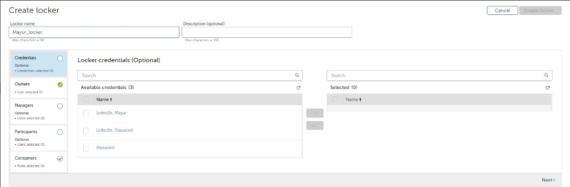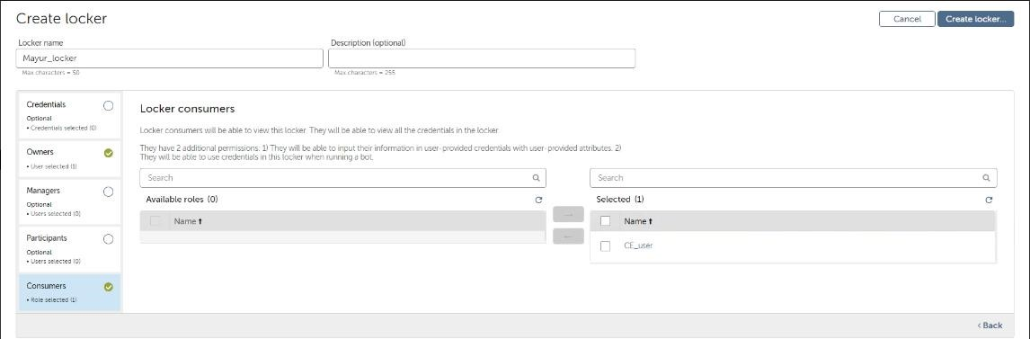

**Step 8:** Add a capture control to select password as object. Select the browser and click on capture object. Capture the password object.

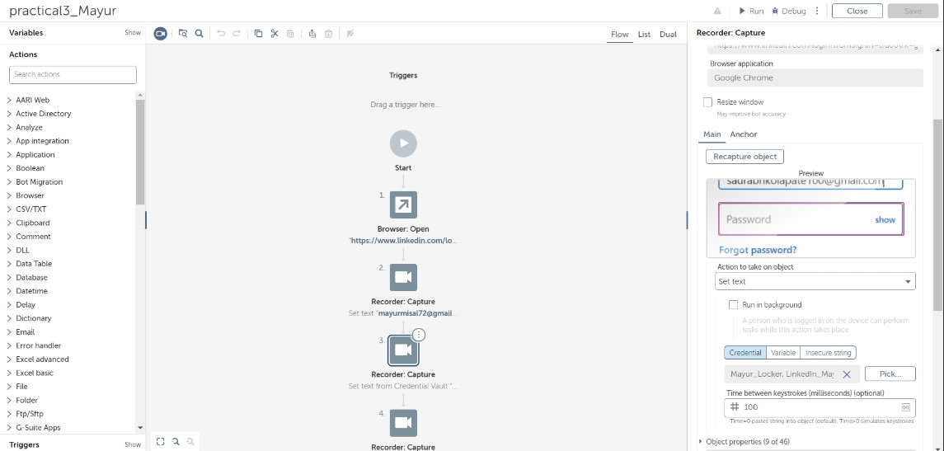

**Step 9:** Select action as Set Text and click on pick to choose the credentials created.Choose the Locker name, Credential name and Attribute name created for LinkedIn and click on “Confirm”.

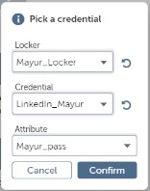

**Step 10:** Add one more capture control to select the Sign In button as object.

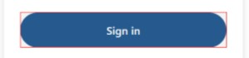

**Step 11:** Choose the action as click and save the bot. Run the bot. The LinkedIn Home page should open.

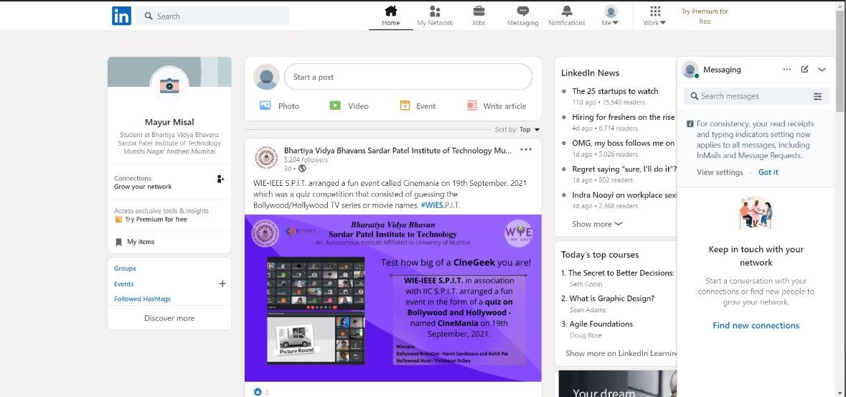

**Step 12:** To share the post on linked list, add mouse: click control and select the browser page as /feed from linkedIn. Click on capture object and select “Start a Post” option as shown below.

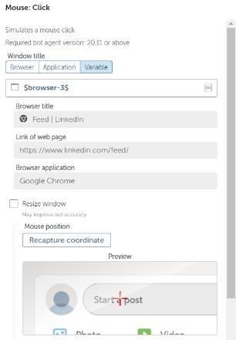

**Step 13:** Select left button to click from the mouse and Event as Click.

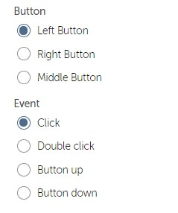

**Step 14:** Add a recorder: capture control and choose the browser. Capture the text box to enter the Text of Post as shown below.

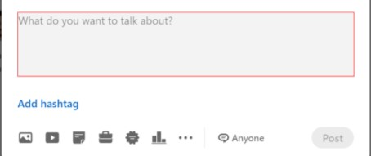

The Capture control should look like below image.

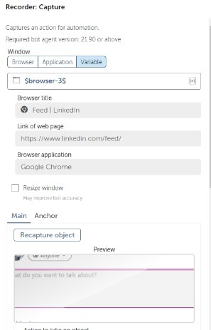

**Step 15:** Choose the Action as “set text” and enter the text of the post in the keystrokes.

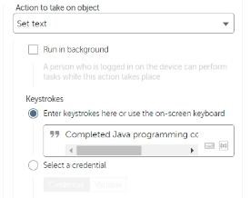

**Step 16:** Add a mouse: click event to click on the upload photo option of LinkedIN. In the Mouse Click Control, select the browser of LinkedIn Feed and capture the “Add a photo” option from browser.

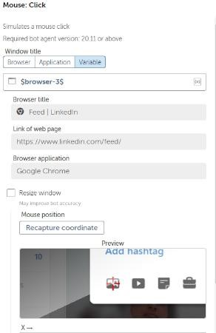

**Step 17:** Keep the button as left and Click as Event.

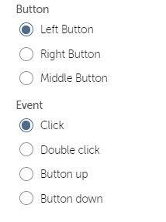

**Step 18:** Add Wait: for screen change to wait for browser to open new window. Choose the Screen resolution as given in the image below and select the time for the bot to wait for the new window.

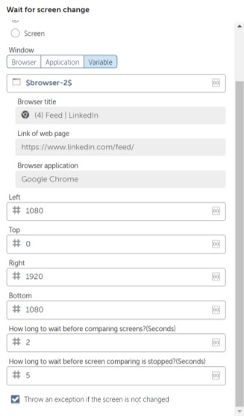

**Step 19:** Save the Bot.

**Step 20:** Use the Moue: click control to go to the file where image is stored.

**Step 21:** Add Mouse Click Control, select the browser and capture the image to click on it.

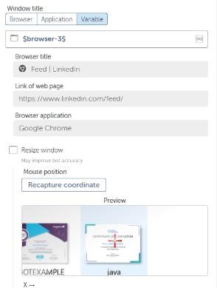

**Step 22:** Add a Mouse Click Control, select the browser and capture “open” button to click.

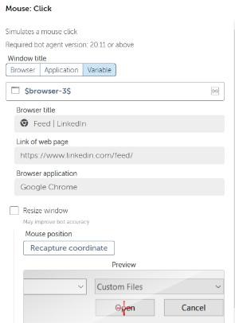

**Step 23:** Add another Mouse Click control to click on “Done”. Select the browser and capture the “Done” button to click.

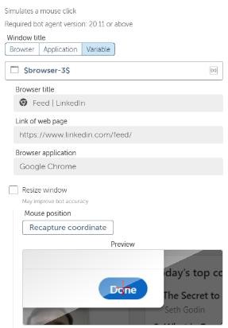

**Step 24:** Add Wait for Screen Change to let the bot change to previous window of Post. Select the browser, give screen resolution as shown in the image and add the screen wait time for bot to wait.

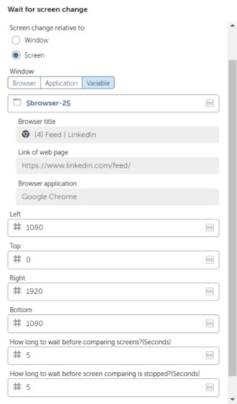

**Step 25:** Add one last Mouse Click control to click on ”Post” button. Select the browser and capture the post button to click and save the bot.

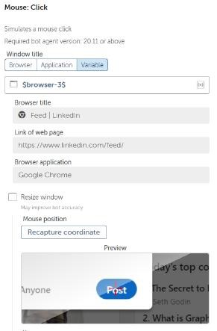

**Step 26**: After successful execution image should get uploaded on linkedIn.

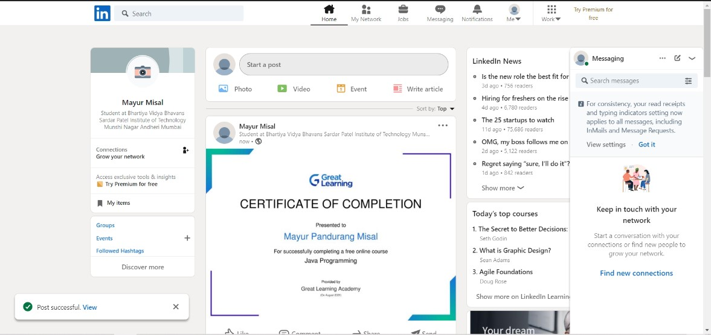

The final bot will look like the image shown below.

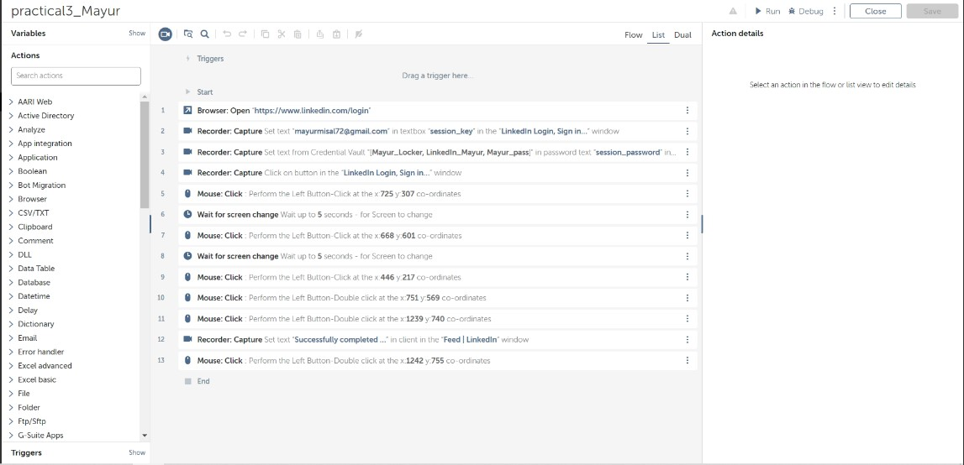

**Conclusion:**

In this practical we have created a bot using Automation anywhere to upload a post on the LinkedIn. For this practical we have used different controls of different actions like Browser: open, Recorder: capture, Wait: for screen change, Mouse: click etc. The bot will first log in to the LinkedIn account by entering email and password. Then it will select "start a post" option from the home page of LinkedIn. It will select an Image from system. It will add caption and finally it will post it on LinkedIn wall. This bot is a simple example of social bot.